**HALLTICKET NUMBER: 2403A52373**

**NAME:KODURU ESWAR REDDY**

**1.Prompt:** generate a Python code if a string is a valid palindrome (ignoring spaces and case)

**Code:**

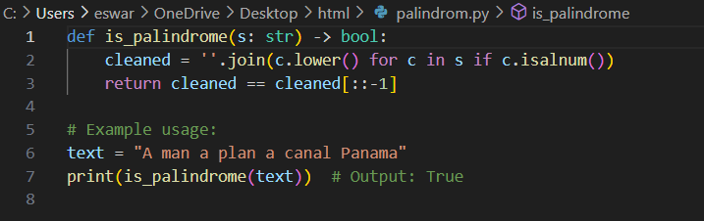

**Code explanation:**

🔹 Short Explanation:

* Removes spaces and special characters (if c.isalnum())
* Converts all letters to lowercase (c.lower())
* Compares the cleaned string with its reverse (cleaned[::-1])
* Returns True if it's a palindrome, otherwise False

**Output:**

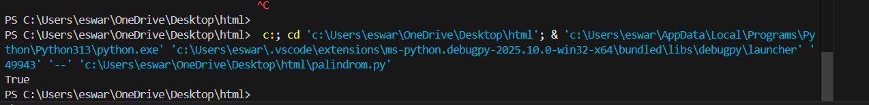

**2.Prompt:** generate a Python function that returns the Fibonacci sequence up to n terms with only a function header and doc string

**Code:**

**Code explanation:**

The function fibonacci_sequence(n) generates the first n numbers in the Fibonacci sequence:

* Starts with 0 and 1
* Each next number is the sum of the previous two
* Repeats this n times and returns the list

**Output:**

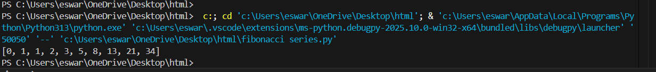

**3.Prompt:** give me a python code to reverse a string

**Code:**

**Code explanation:**

The function reverse_string(s) returns the input string in reverse order using slicing s[::-1].

**Output:**

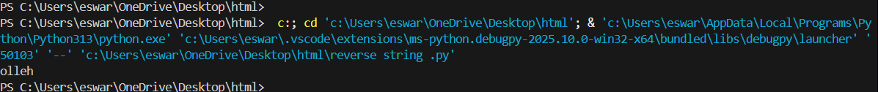

**4.Prompt** **:** Generate a Python program that simulates a basic calculator (add, subtract, multiply, divide)

**Code:**

**Code explanation:**

Defines four basic calculator functions:

* add(a, b) → returns a + b
* subtract(a, b) → returns a - b
* multiply(a, b) → returns a * b
* divide(a, b) → returns a / b (handles division by zero)

**Output:**

**5.Prompt:** generate a python code to read a file and return the number of lines with open() and readlines()

**Code:**

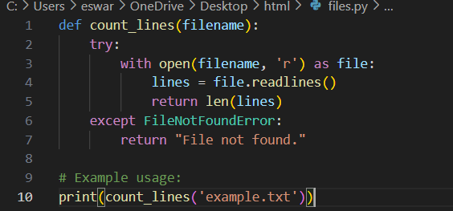

**Code explanation:**

count_lines(filename) counts and returns the **number of lines** in a given file.

**🔹 How:**

* Opens the file in read mode
* Reads all lines into a list
* Returns the length of that list using len(lines)

**Output:**

